Why we cannot compare two objects having same properties inside ?

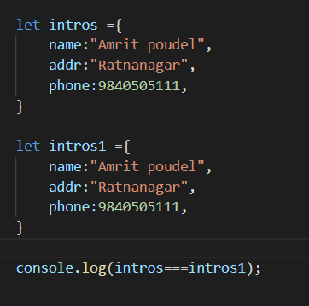

Here even if two objects have same properties inside they both points to different memory locations so they are not same, so returns false

=== actually checks whether two comparing items are of same reference or not